UNIT – 4
80386 AND 80486 MICROPROCESSORS: Introduction, programming concepts, special purpose registers, memory organization, moving to protected mode, virtual mode, memory paging mechanism, architectural differences between 80386 and 80486 microprocessors.
*****
1. List the salient features of 80386DX microprocessor.
80386 Microprocessor is a 32-bit processor that holds the ability to carry out 32-bit operation in one cycle. It has data and address bus of 32-bit each. Thus has the ability to address 4 GB (or 2³²) of physical memory. Multitasking and protection capability are the two key characteristics of 80386 microprocessor. 80386 has an internal dedicated hardware that permits multitasking. The 8086 is a 16-bit microprocessor and 80286 was an advancement of 8086 with some additional characteristics. But with the advent of technology Intel introduced a 32-bit microprocessor whose processing speed was twice as that of 80286 microprocessor. This was 80386 microprocessor that was designed by Intel in October 1985 and was an upgraded version of 80286 microprocessor.

Features of 80386
- As it is a 32-bit microprocessor. Thus has 32-bit ALU.
- 80386 has data bus of 32-bit.
- It holds address bus of 32 bit.
- It supports physical memory addressability of 4 GB and virtual memory addressability of 64 TB.
- 80386 supports variety of operating clock frequency, which are 16 MHz, 20 MHz, 25 MHz and 33 MHz.
- It offers 3 stage pipeline: fetch, decode and execute. As it supports simultaneous fetching, decoding and execution inside the system.
2. Explain the use of segment descriptor register and control registers of 80386.
Segment Descriptor Registers: This registers are not available for programmers, rather they are internally used to store the descriptor information, like attributes, limit and base addresses of segments.
• The six segment registers have corresponding six 73 bit descriptor registers. Each of them contains 32 bit base address, 32 bit base limit and 9 bit attributes. These are automatically loaded when the corresponding segments are loaded with selectors.
Segment Descriptor format
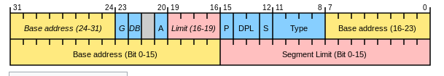
The A (accessed) attributed bit indicates whether the segment has been accessed by the CPU or not.
•The TYPE field decides the descriptor type and hence the segment type.
•The S bit decides whether it is a system descriptor (S=0) or code/data segment descriptor ( S=1).
•The DPL field specifies the descriptor privilege level.
•The D bit specifies the code segment operation size. If D=1, the segment is a 32-bit operand segment, else, it is a 16-bit operand segment.
•The P bit (present) signifies whether the segment is present in the physical memory or not. If P=1, the segment is present in the physical memory.
•The G (granularity) bit indicates whether the segment is page addressable. The zero bit must remain zero for compatibility with future process.
•The AVL (available) field specifies whether the descriptor is for user or for operating system.
•The 80386 has five types of descriptors listed as follows:
1. Code or Data Segment Descriptors. 2. System Descriptors. 3. Local descriptors. 4. TSS (Task State Segment) Descriptors. 5. GATE Descriptors.
•The 80386 provides a four level protection mechanism.

Control Registers: The 80386 has three 32 bit control registers CR0, CR2 and CR3 to hold global machine status independent of the executed task.
•Load and store instructions are available to access these registers
•Common tasks performed by control registers include interrupt control, switching the addressing mode, paging control, and coprocessor control.
•CR0 contains system control flags, which control or indicate conditions that apply to the system as a whole, not to an individual task.
•PE (Protection Enable, bit 0): Setting PE causes the processor to begin executing in protected mode. Resetting PE returns to real-address mode.
•MP (Math Present, bit 1): MP controls the function of the WAIT instruction, which is used to coordinate a coprocessor.
•EM (Emulation, bit 2):EM indicates whether coprocessor functions are to be emulated.
•TS (Task Switched, bit 3):The processor sets TS with every task switch and tests TS when interpreting coprocessor instructions.
•ET (Extension Type, bit 4):ET indicates the type of coprocessor present in the system (80287 or 80387).
•PG (Paging, bit 31): PG indicates whether the processor uses page tables to translate linear addresses into physical addresses.

CR2:
•CR2 is used for handling page faults when PG is set. The processor stores in CR2 the linear address that triggers the fault.
•Contains a value called Page Fault Linear Address (PFLA). When a page fault occurs, the address the program attempted to access is stored in the CR2 register.
CR3: Used when virtual addressing is enabled, hence when the PG bit is set in CR0, CR3 enables the processor to translate linear addresses into physical addresses by locating the page directory and page tables for the current task.
•Typically, the upper 20 bits of CR3 become the page directory base register (PDBR), which stores the physical address of the first page directory entry.
CR1: Reserved for Intel future purpose.
3. List and discuss different data types supported by 80386 microprocessor.
The 80386 supports the following data types they are
- Bit
- Bit Field: A group of at the most 32 bits (4bytes)
- Bit String: A string of contiguous bits of maximum 4Gbytes in length.
- Signed Byte: Signed byte data
- Unsigned Byte: Unsigned byte data.
- Integer word: Signed 16-bit data.
- Long Integer: 32-bit signed data represented in 2's complement form.
- Unsigned Integer Word: Unsigned 16-bit data
- Unsigned Long Integer: Unsigned 32-bit data
- Signed Quad Word: A signed 64-bit data or four word data.
- Unsigned Quad Word: An unsigned 64-bit data.
- Offset: 16/32-bit displacement that points a memory location using any of the addressing modes.
- Pointer: This consists of a pair of 16-bit selector and 16/32-bit offset.
- Character: An ASCII equivalent to any of the alphanumeric or control characters.
- Strings: These are the sequences of bytes, words or double words. A string may contain minimum one byte and maximum 4 Gigabytes.
- BCD: Decimal digits from 0-9 represented by unpacked bytes.
- Packed BCD: This represents two packed BCD digits using a byte, i.e. from 00 to 99.

4. Draw and discuss the register set of 80386 and explain the functions of registers in brief.

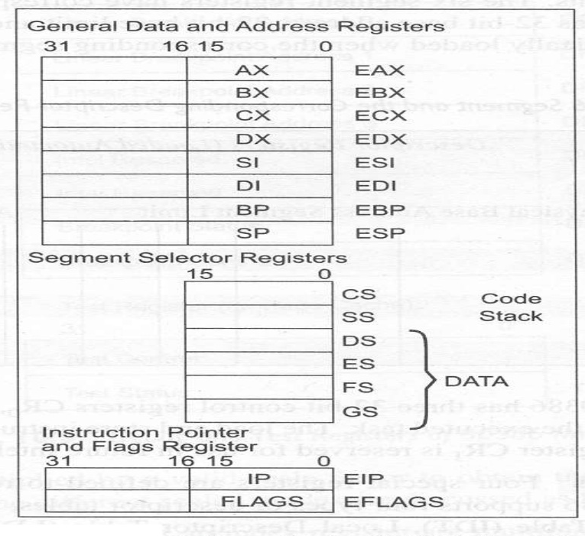
Register Organisation
•The 80386 has eight 32 - bit general purpose registers which may be used as either 8 bit or 16 bit registers.
•A 32 - bit register known as an extended register, is represented by the register name with prefix E.
Example : A 32 bit register corresponding to AX is EAX, similarly BX is EBX etc.
•The 16 bit registers BP, SP, SI and DI in 8086 are now available with their extended size of 32 bit and are names as EBP,ESP,ESI and EDI.
•AX represents the lower 16 bit of the 32 bit register EAX.
• BP, SP, SI, DI represents the lower 16 bit of their 32 bit counterparts, and can be used as independent 16 bit registers.
•The six segment registers available in 80386 are CS, SS, DS, ES, FS and GS.
•The CS and SS are the code and the stack segment registers respectively, while DS, ES, FS, GS are 4 data segment registers.
•A 16 bit instruction pointer IP is available along with 32 bit counterpart EIP.
•Flag Register of 80386: The Flag register of 80386 is a 32 bit register. Out of the 32 bits, Intel has reserved bits D18 to D31, D5 and D3, while D1 is always set at 1.
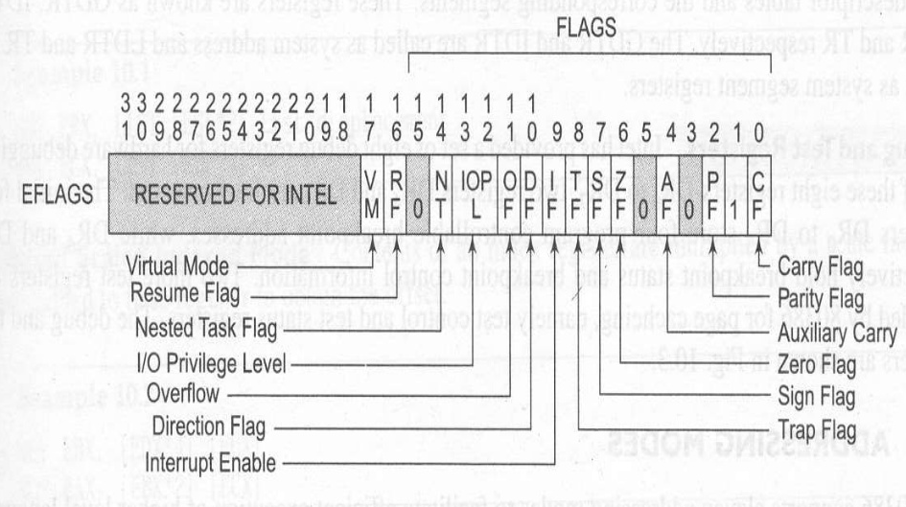

•VM - Virtual Mode Flag: If this flag is set, the 80386 enters the virtual 8086 mode within the protection mode. This is to be set only when the 80386 is in protected mode. In this mode, if any privileged instruction is executed an exception 13 is generated. This bit can be set using IRET instruction or any task switch operation only in the protected mode.
•RF- Resume Flag: This flag is used with the debug register breakpoints. It is checked at the starting of every instruction cycle and if it is set, any debug fault is ignored during the instruction cycle. The RF is automatically reset after successful execution of every instruction, except for IRET and POPF instructions.
•Also, it is not automatically cleared after the successful execution of JMP, CALL and INT instruction causing a task switch. These instructions are used to set the RF to the value specified by the memory data available at the stack. •Segment Descriptor Registers: This registers are not available for programmers, rather they are internally used to store the descriptor information, like attributes, limit and base addresses of segments.
The six segment registers have corresponding six 73 bit descriptor registers. Each of them contains 32 bit base address, 32 bit base limit and 9 bit attributes. These are automatically loaded when the corresponding segments are loaded with selectors.
•Control Registers: The 80386 has three 32 bit control registers CR0, CR2 and CR3 to hold global machine status independent of the executed task. Load and store instructions are available to access these registers.
•System Address Registers: Four special registers are defined to refer to the descriptor tables supported by 80386. •The 80386 supports four types of descriptor table, viz. global descriptor table (GDT), interrupt descriptor table (IDT), local descriptor table (LDT) and task state segment descriptor (TSS).
•Debug and Test Registers: Intel has provide a set of 8 debug registers for hardware debugging. Out of these eight registers DR0 to DR7, two registers DR4 and DR5 are Intel reserved.
•The initial four registers DR0 to DR3 store four program controllable breakpoint addresses, while DR6 and DR7 respectively hold breakpoint status and breakpoint control information.
•Two more test register are provided by 80386 for page caching namely test control and test status register.

5. Enlist the additional features of 80486 over 80386 microprocessor.
S.No | Description | 80386 | 80486
1 | Processor Speed | 50MHz | 66MHz
2 | Math Coprocessor | 80387 External | Internal
3 | Pins | 132 | 168
4 | Execution Speed | 27MIPS | 54MIPS
5 | Instruction Cache | 16 Byte | 32 Bytes
6 | Data Cache | 256 Bytes | 8Kbytes
7 | Flags | 13  (C,P,A,Z,S,T,D,I,O,IOPL,NT,RF,VM) | 14  (C,P,A,Z,S,T,D,I,O,IOPL,NT,RF,VM,AC)
8 | Year Introduction | 1985 | 1989

6. Explain the physical address formation in real address mode of 80386 microprocessor.
Real Address Mode of 80386
•After reset, the 80386 starts from memory location FFFFFFF0H under the real address mode. In the real mode, 80386 works as a fast 8086 with 32-bit registers and data types.
•In real mode, the default operand size is 16 bit but 32- bit operands and addressing modes may be used with the help of override prefixes.
•The segment size in real mode is 64k, hence the 32-bit effective addressing must be less than 0000FFFFFH. The real mode initializes the 80386 and prepares it for protected mode.
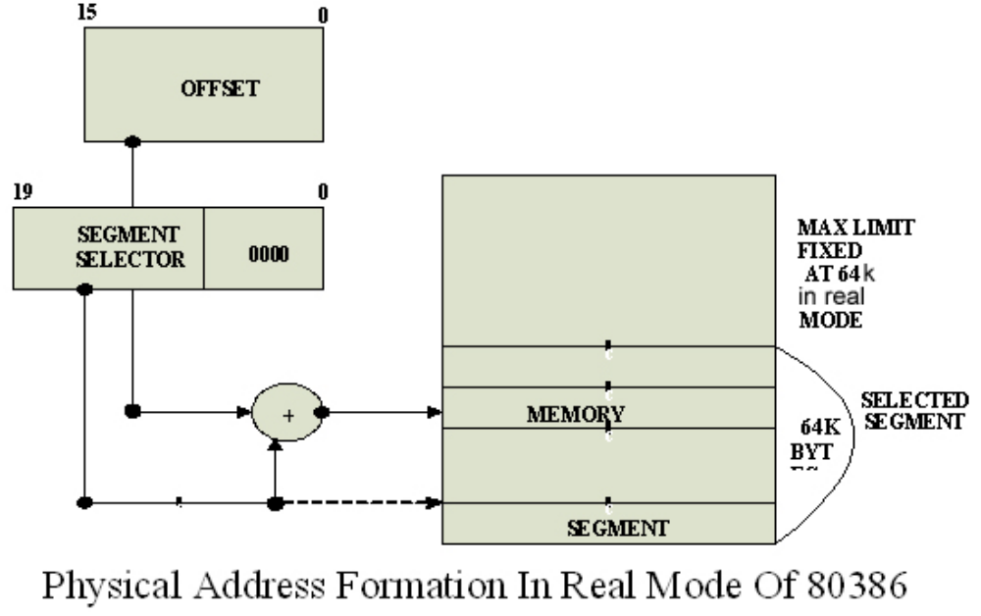
Memory Addressing in Real Mode: In the real mode, the 80386 can address at the most 1Mbytes of physical memory using address lines A0-A19.
•Paging unit is disabled in real addressing mode, and hence the real addresses are the same as the physical addresses.
•To form a physical memory address, appropriate segment registers contents (16-bits) are shifted left by four positions and then added to the 16-bit offset address formed using one of the addressing modes, in the same way as in the 80386 real address mode.
•The segment in 80386 real mode can be read, write or executed, i.e. no protection is available.
•Any fetch or access past the end of the segment limit generates exception 13 in real address mode.
•The segments in 80386 real mode may be overlapped or non-overlapped.
•The interrupt vector table of 80386 has been allocated 1Kbyte space starting from 00000H to 003FFH.

7. What is meant by paging? What are its advantages and disadvantages? OR Draw and discuss the paging mechanism of 80386 in detail.

PAGING OPERATION: Paging is one of the memory management techniques used for virtual memory multitasking operating system.
•The segmentation scheme may divide the physical memory into a variable size segments but the paging divides the memory into a fixed size pages.
•The segments are supposed to be the logical segments of the program, but the pages do not have any logical relation with the program.
•The pages are just fixed size portions of the program module or data.
•The advantage of paging scheme is that the complete segment of a task need not be in the physical memory at any time.
•Only a few pages of the segments, which are required currently for the execution need to be available in the physical memory. Thus the memory requirement of the task is substantially reduced, relinquishing the available memory for other tasks.
•Whenever the other pages of task are required for execution, they may be fetched from the secondary storage.
•The previous page which are executed, need not be available in the memory, and hence the space occupied by them may be relinquished for other tasks.
•Thus paging mechanism provides an effective technique to manage the physical memory for multitasking systems.
•Paging Unit: The paging unit of 80386 uses a two level table mechanism to convert a linear address provided by segmentation unit into physical addresses.
•The paging unit converts the complete map of a task into pages, each of size 4K. The task is further handled in terms of its page, rather than segments.
•The paging unit handles every task in terms of three components namely page directory, page tables and page itself.
•Paging Descriptor Base Register: The control register CR2 is used to store the 32-bit linear address at which the previous page fault was detected.
•The CR3 is used as page directory physical base address register, to store the physical starting address of the page directory.
•The lower 12 bit of the CR3 are always zero to ensure the page size aligned directory. A move operation to CR3 automatically loads the page table entry caches and a task switch operation, to load CR0 suitably.
•Page Directory : This is at the most 4Kbytes in size. Each directory entry is of 4 bytes, thus a total of 1024 entries are allowed in a directory.
•The upper 10 bits of the linear address are used as an index to the corresponding page directory entry. The page directory entries point to page tables.
•Page Tables: Each page table is of 4Kbytes in size and many contain a maximum of 1024 entries. The page table entries contain the starting address of the page and the statistical information about the page.
•The upper 20 bit page frame address is combined with the lower 12 bit of the linear address. The address bits A12- A21 are used to select the 1024 page table entries. The page table can be shared between the tasks.
•The P bit of the above entries indicate, if the entry can be used in address translation.
•If P=1, the entry can be used in address translation, otherwise it cannot be used.
•The P bit of the currently executed page is always high.
•The accessed bit A is set by 80386 before any access to the page. If A=1, the page is accessed, else unaccessed.
•The D bit (Dirty bit) is set before a write operation to the page is carried out. The D-bit is undefined for page director entries.
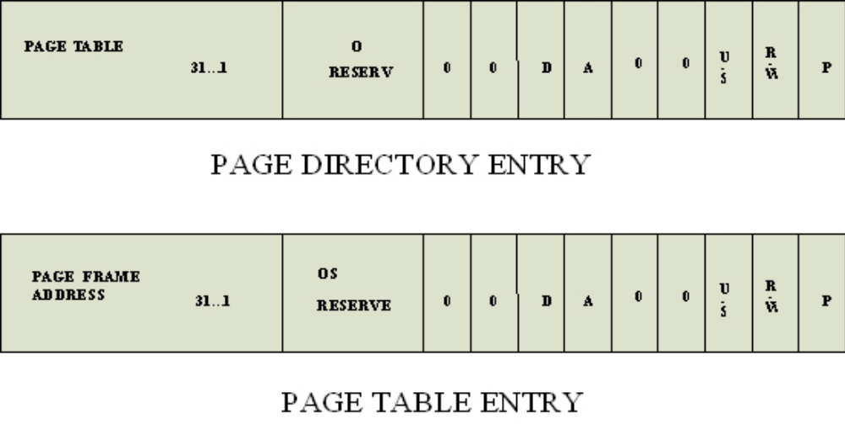

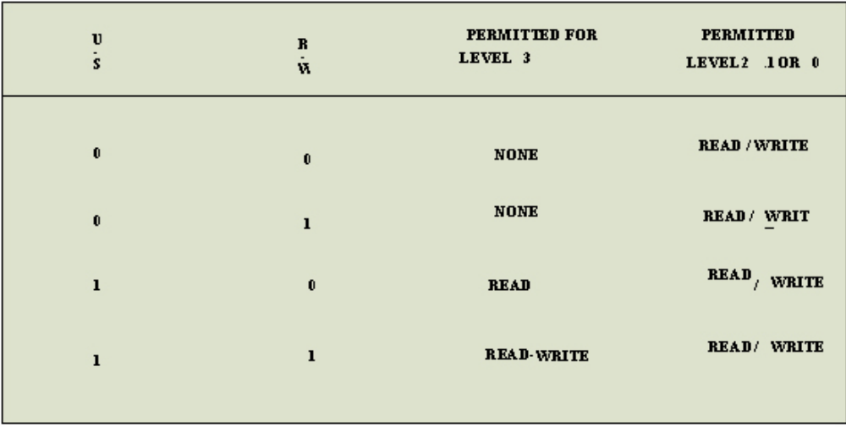
•The OS reserved bits are defined by the operating system software.
•The User / Supervisor (U/S) bit and read/write bit are used to provide protection. These bits are decoded to provide protection under the 4 level protection model.
•The level 0 is supposed to have the highest privilege, while the level 3 is supposed to have the least privilege.
•This protection provide by the paging unit is transparent to the segmentation unit.
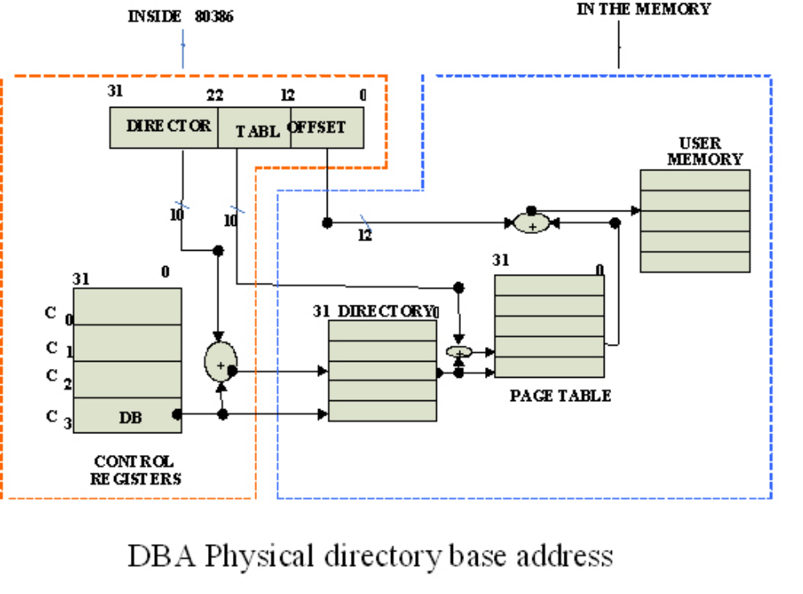

8. What is virtual memory?
Virtual Memory is a computer concept where the main memory is broken up into a series of individual pages. Those pages can be moved in memory as a unit, or they can even be moved to secondary storage to make room in main memory for new data. In essence, virtual memory allows a computer to use more RAM than it has available.
If a simple virtual==physical address path is adequate for your CPU, you don't need virtual memory.
Most processors have a very simple address path -- address bits come from the PC or some other programmer-visible register, or directly from some instruction, and they are directly applied to the address bus.
Many general-purpose processors have a more complex address path: user-level programs run as if they have a simple address path, but the physical address applied to the address bus is significantly different than the programmer-visible address. This enables virtual memory, memory protection, and other desirable features.
If your CPU needs to do this, then you need something to translate user-visible addresses to physical address -- either design the CPU to connect to some off-chip bank register or MMU (such as the 8722 MMU or the 68851 MMU) or design in an on-chip bank register or MMU.
You may want to do this in order to:
- support various debug tools that trap on reads or writes to selected addresses.
- allow access to more RAM (wider physical address) than the user-level address seems to support (banking)
- support many different programs all in RAM at the same time at different physical RAM locations, even though they were all compiled to run at location 0x300.
- allow a program to successfully read and write a large block of data using normal LOAD and STORE instructions as if it were all in RAM, even though the machine doesn't have that much RAM (paging with virtual memory)
- support a "protected" supervisor-level system that can run buggy or malicious user-level code in an isolated sandbox at full speed without damaging other user-level programs or the supervisor system itself -- Popek and Goldberg virtualization, W xor X memory protection, etc.
- or some combination of the above.

9. What is meant by a cache memory? How does it speed up the program execution? Explain.
A memory is just like a human brain. It is used to store data and instructions. Computer memory is the storage space in the computer, where data is to be processed and instructions required for processing are stored. The memory is divided into large number of small parts called cells. Each location or cell has a unique address, which varies from zero to memory size minus one. For example, if the computer has 64k words, then this memory unit has 64 * 1024 = 65536 memory locations. The address of these locations varies from 0 to 65535.
Memory is primarily of three types −
- Cache Memory
- Primary Memory/Main Memory
- Secondary Memory

Cache Memory
Cache memory is a very high speed semiconductor memory which can speed up the CPU. It acts as a buffer between the CPU and the main memory. It is used to hold those parts of data and program which are most frequently used by the CPU. The parts of data and programs are transferred from the disk to cache memory by the operating system, from where the CPU can access them.

Advantages
The advantages of cache memory are as follows −
- Cache memory is faster than main memory.
- It consumes less access time as compared to main memory.
- It stores the program that can be executed within a short period of time.
- It stores data for temporary use.

Disadvantages
The disadvantages of cache memory are as follows −
- Cache memory has limited capacity.
- It is very expensive.
11. Explain the different addressing modes of 80386 processor with examples.
- Addressing modes indicate a way of locating data or operands.
- Described the type of operands and the way they are accessed for executing an instruction.
- The method by which address of source data and address of destination of result is given in the instruction is called as “Addressing Modes”.
The 80386 Microprocessor Provide 11 addressing modes.
- Register addressing Mode
- Immediate addressing Mode
- Direct addressing Mode
- Register Indirect addressing Mode
- Based addressing Mode
- Index addressing Mode
- Scaled Index addressing Mode
- Based Index addressing Mode
- Based Scaled Index addressing Mode
- Based Index addressing Mode with Displacement
- Based Scaled Index addressing Mode with Displacement
Register addressing Mode
The data is stored in a register and it is referred using a particular register. All register accept IP used in this addressing mode. The 8/16/32 bit data required to execute an instruction is present in 8/16/32 bit register is given along with the instruction is called “Register addressing mode. “
Example: ADD EAX,EBX
Immediate addressing Mode
In this addressing mode, immediate data is part of instruction. The 8/16/32 bit data required to execute an instruction is given directly along with the instruction is called “Immediate addressing mode”.
Example: Mov EAX, 12345678H
Direct addressing Mode
The 8/16/32 bit data required to execute an instruction is present in memory location and effective address of this memory location is given directly along with the instruction then it is called “Direct addressing mode”. Example : Mov AX,[5000H]
Register Indirect addressing Mode
A base register will contain the address of operand ▪ Example: MOV [ECX], EDX The 8/16/32 bit data required to execute an instruction is present in memory location and effective address of that memory location is present in a 32 bit register and the name of this register is given along with the instruction then it is called “Register Indirect addressing mode”.
Based addressing Mode
A BASE register's contents is added to a DISPLACEMENT to form the operands offset.
Example: MOV ECX, [EAX+24]
Index addressing Mode
An INDEX register's contents is added to a DISPLACEMENT to form the operands offset.
EXAMPLE: ADD EAX, TABLE[ESI]
The 8/16/32 bit data required to execute an instruction is present in memory location and effective address of that memory location is obtained by adding three contents : 1. The 32 bit content of base register 2. The 32 bit content of Index Register 3. Displacement.
The 80386 have a family of scaled modes. In the case of scaled modes, any of the index register values can be multiplied by a valid scale factor to obtain the displacement. The valid scale factors are 1,2, 4, and 8.
Scaled Indexed Mode: The contents of an index register are multiplied by a scale factor that may be added further to get the operand offset. Ex. MOV EBX, LIST [ESI* 2] MUL ECX, LIST [EBP*4]
Based Scaled Indexed mode: The contents of an index register are multiplied by a scale factor and then added to base register to obtain the offset. Ex: MOV EBX, [EDX*4] [ECX] MOV EAX, [EBX*2] [ECX].
Based scaled indexed mode with displacement: the contents of an index register are multiplied by a scale factor and the result is added to a base register and a displacement to get the offset of an operand. Ex: MOV EAX, LIST [ESI* 2] [EBX+0800] MUL EBX, LIST [EDI*8] [ECX+0100].
12. Draw and explain the virtual 8086 mode of 80386 processor in detail.
Virtual 8086 Mode
•In its protected mode of operation, 80386DX provides a virtual 8086 operating environment to execute the 8086 programs.
•The real mode can also used to execute the 8086 programs along with the capabilities of 80386, like protection and a few additional instructions.
•Once the 80386 enters the protected mode from the real mode, it cannot return back to the real mode without a reset operation.
•Thus, the virtual 8086 mode of operation of 80386, offers an advantage of executing 8086 programs while in protected mode.
•The address forming mechanism in virtual 8086 mode is exactly identical with that of 8086 real mode.
•In virtual mode, 8086 can address 1Mbytes of physical memory that may be anywhere in the 4Gbytes address space of the protected mode of 80386.
•Like 80386 real mode, the addresses in virtual 8086 mode lie within 1Mbytes of memory.
•In virtual mode, the paging mechanism and protection capabilities are available at the service of the programmers.
•The 80386 supports multiprogramming, hence more than one programmer may be use the CPU at a time.
•Paging unit may not be necessarily enable in virtual mode, but may be needed to run the 8086 programs which require more than 1Mbyts of memory for memory management function.
•In virtual mode, the paging unit allows only 256 pages, each of 4Kbytes size.
•Each of the pages may be located anywhere in the maximum 4Gbytes physical memory.
The virtual mode allows the multiprogramming of 8086 applications.
•The virtual 8086 mode executes all the programs at privilege level 3.Any of the other programmes may deny access to the virtual mode programs or data.
•However, the real mode programs are executed at the highest privilege level, i.e. level 0.
•The virtual mode may be entered using an IRET instruction at CPL=0 or a task switch at any CPL, executing any task whose TSS is having a flag image with VM flag set to 1.
•The IRET instruction may be used to set the VM flag and consequently enter the virtual mode.
•The PUSHF and POPF instructions are unable to read or set the VM bit, as they do not access it.
•Even in the virtual mode, all the interrupts and exceptions are handled by the protected mode interrupt handler.
•To return to the protected mode from the virtual mode, any interrupt or execution may be used.
•As a part of interrupt service routine, the VM bit may be reset to zero to pull back the 80386 into protected mode.
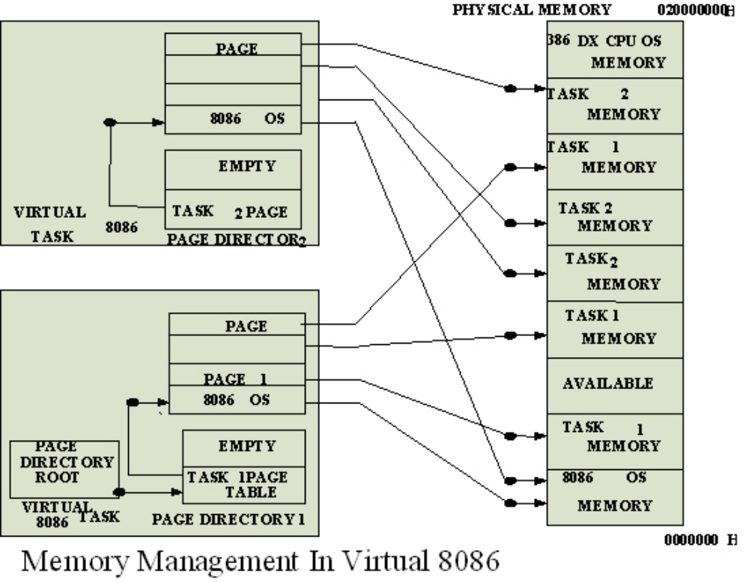
13. Draw the internal architecture of 80386 processor and explain its operation in detail.
Architecture of 80386
Basically it has 3 functional units which are as follows:
- Bus Interface Unit
- Central Processing Unit
  - Instruction Decode Unit
  - Execution Unit
- Memory Management Unit
  - Segmentation Unit
  - Paging Unit

1. Bus Interface Unit
The bus interface unit or BIU holds a 32-bit bidirectional data bus as well as 32-bit address bus. Whenever a need for an instruction or a data fetch is generated by the system then the BIU generates signals (according to the priority) for activating the data and address bus in order to fetch the data from the desired address.
The BIU connects the peripheral devices through the memory unit and also controls the interfacing of external buses with the coprocessors.

2. Code Prefetch Unit
This unit fetches the instructions stored in the memory by making use of system buses. Whenever the system generates a need for an instruction then the code prefetch unit fetches that instruction from the memory and stores it in 16-byte prefetch queue.
So to speed up the operation this unit fetches the instructions in advance and the queue stores these instructions.
The sequence in which the instructions are fetched and gets stored in the queue depends on the order they exist in the memory.
As this unit fetches one double word in single access. So, in such a case, it is not necessary that each time only a single instruction will be fetched, as the fetched instruction can be parts of two different instructions.
It is to be noted here that, code prefetching holds lower priority than data transferring. As whenever, a need for data transfer is generated by the system then immediately the code prefetcher leaves the control over the buses. So that the BIU can transfer the required data.
But prefetching of instruction and storing it in the queue reduces the wait for the upcoming instruction to almost zero.

3. Instruction Decode Unit
We know that instructions in the memory are stored in the form of bits. So, this unit decodes the instructions stored in the prefetch queue. Basically the decoder changes the machine language code into assembly language and transfers it to the processor for further execution.

4. Execution Unit
The decoded instructions are stored in the decoded instruction queue. So, these instructions are provided to the execution unit in order to execute the instructions.
The execution unit controls the execution of the decoded instructions. This unit has a 32-bit ALU, that performs the operation over 32-bit data in one cycle. Also, it consists of 8 general purpose as well as 8 special purpose registers. These are used for data handling and calculation of offset address.

5. Memory Management Unit
This unit has two separate units within it. These are
- Segmentation Unit and
- Paging Unit
Segmentation unit: The segmentation unit plays a vital role in the 80836 microprocessor. It offers protection mechanism in order to protect the code or data present in the memory from application programs.
It gives 4 level protection to the data or code present in the memory. Every information in the memory is assigned a privilege level from PL0 to PL3. Here, PL0 holds the highest priority and PL3 holds the lowest priority.
Suppose a file (either data or code) is needed to be accessed is stored in the memory at PL0. Then only those programs which are working at PL0 would be able to access that file. While other programs will not be able to access the same.
Also, if a file is present at PL1, then programs of PL0 and PL1 both can access it. As PL0 has higher priority than PL1. So, for protection purpose the main part of OS is stored in PL0 while PL3 holds the user programs.
Providing protection to the data or code inside the system is the most advantageous factor that was first given by 80386 microprocessor.
Paging Unit: The paging unit operates only in protected mode and it changes the linear address into physical address. As the programmer only provides the virtual address and not the physical address.
The segmentation unit controls the action of paging unit, as the segmentation unit has the ability to convert logical address into linear address at the time of executing an instruction.
Basically it changes the overall task map into pages and each page has a size of 4K. This allows the handling of task in the form of pages rather than segments.
Paging unit supports multitasking. This is so because the physical memory is not required to hold the whole segment of any task. Despite, only that part of the segment which is needed to be currently executed must be stored in that memory whose physical address is calculated by the paging unit.
This resultantly reduces the memory requirement and hence this frees the memory for other tasks. Thus by this we get an effective way for managing the memory to support multitasking.
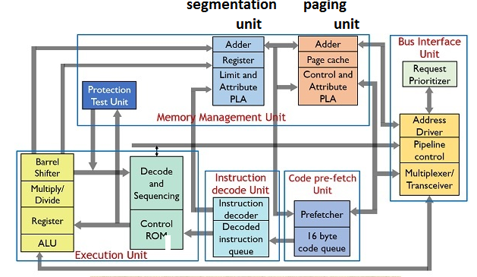

14. Draw the EFLAG register of 80386 processor and explain the function of each flag with example.
Flag Register of 80386: The Flag register of 80386 is a 32 bit register. Out of the 32 bits, Intel has reserved bits D18 to D31, D5 and D3, while D1 is always set at 1.

•VM - Virtual Mode Flag: If this flag is set, the 80386 enters the virtual 8086 mode within the protection mode. This is to be set only when the 80386 is in protected mode. In this mode, if any privileged instruction is executed an exception 13 is generated. This bit can be set using IRET instruction or any task switch operation only in the protected mode.
•RF- Resume Flag: This flag is used with the debug register breakpoints. It is checked at the starting of every instruction cycle and if it is set, any debug fault is ignored during the instruction cycle. The RF is automatically reset after successful execution of every instruction, except for IRET and POPF instructions.
Bit | Label | EFLAGS Flag Description
0 | CF | Carry Flag: Set by arithmetic instructions which generate either a carry or borrow. Set when an operation generates a carry to or a borrow from a destination operand.
2 | PF | Parity flag: Set by most CPU instructions if the least significant (aka the low-order bits) of the destination operand contain an even number of 1's.
4 | AF | Auxiliary Carry Flag: Set if there is a carry or borrow involving bit 4 of EAX. Set when a CPU instruction generates a carry to or a borrow from the low-order 4 bits of an operand. This flag is used for binary coded decimal (BCD) arithmetic.
6 | ZF | Zero Flag: Set by most instructions if the result an operation is binary zero.
7 | SF | Sign Flag: Most operations set this bit the same as the most significant bit (aka high-order bit) of the result. 0 is positive, 1 is negative.
8 | TF | Trap Flag: (sometimes named a Trace Flag.) Permits single stepping of programs. After executing a single instruction, the processor generates an internal exception 1. When Trap Flag is set by a program, the processor generates a single-step interrupt after each instruction. A debugging program can use this feature to execute a program one instruction at a time.
9 | IF | Interrupt Enable Flag: when set, the processor recognizes external interrupts on the INTR pin. When set, interrupts are recognized and acted on as they are received. The bit can be cleared to turn off interrupt processing temporarily.
10 | DF | Direction Flag: Set and cleared using the STD and CLD instructions. It is used in string processing. When set to 1, string operations process down from high addresses to low addresses. If cleared, string operations process up from low addresses to high addresses.
11 | OF | Overflow Flag: Most arithmetic instructions set this bit, indicating that the result was too large to fit in the destination. When set, it indicates that the result of an operation is too large or too small to fit in the destination operand.
12-13 | IOPL | Input/Output privilege level flags: Used in protected mode to generate four levels of security.
14 | NT | Nested Task Flag: Used in protected mode. When set, it indicates that one system task has invoked another via a CALL Instruction, rather than a JMP.
16 | RF | Resume Flag: Used by the debug registers DR6 and DR7. It enables you to turn off certain exceptions while debugging code.
17 | VM | Virtual 8086 Mode flag: Permits 80386 to behave like a high speed 8086.
Although all flags serve a purpose, most programs require only the carry, zero, sign, and direction flags.
15. Explain the protected mode concepts of 80386 Microprocessor.
Protected Mode of 80386
•All the capabilities of 80386 are available for utilization in its protected mode of operation.
•The 80386 in protected mode support all the software written for 80286 and 8086 to be executed under the control of memory management and protection abilities of 80386.
•The protected mode allows the use of additional instruction, addressing modes and capabilities of 80386.
•ADDRESSING IN PROTECTED MODE: In this mode, the contents of segment registers are used as selectors to address descriptors which contain the segment limit, base address and access rights byte of the segment.
•The effective address (offset) is added with segment base address to calculate linear address. This linear address is further used as physical address, if the paging unit is disabled, otherwise the paging unit converts the linear address into physical address.
•The paging unit is a memory management unit enabled only in protected mode. The paging mechanism allows handling of large segments of memory in terms of pages of 4Kbyte size.
•The paging unit operates under the control of segmentation unit. The paging unit if enabled converts linear addresses into physical address, in protected mode.
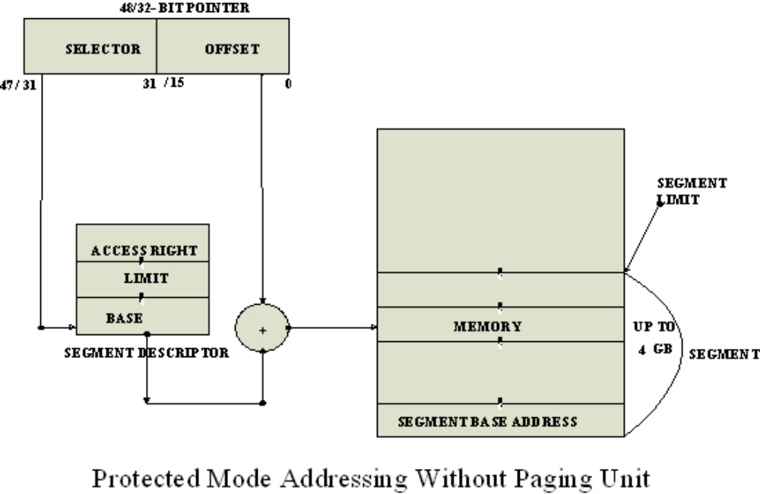
Segmentation
•DESCRIPTOR TABLES: These descriptor tables and registers are manipulated by the operating system to ensure the correct operation of the processor, and hence the correct execution of the program.
•Three types of the 80386 descriptor tables are listed as follows:
•GLOBAL DESCRIPTOR TABLE ( GDT )
•LOCAL DESCRIPTOR TABLE ( LDT )
•INTERRUPT DESCRIPTOR TABLE ( IDT )
•DESCRIPTORS: The 80386 descriptors have a 20-bit segment limit and 32-bit segment address. The descriptor of 80386 are 8-byte quantities access right or attribute bits along with the base and limit of the segments.
•Descriptor Attribute Bits: The A (accessed) attributed bit indicates whether the segmenthas been accessed by the CPU or not.
•The TYPE field decides the descriptor type and hence the segment type.
•The S bit decides whether it is a system descriptor (S=0) or code/data segment descriptor ( S=1).
•The DPL field specifies the descriptor privilege level.
•The D bit specifies the code segment operation size. If D=1, the segment is a 32-bit operand segment, else, it is a 16-bit operand segment.
•The P bit (present) signifies whether the segment is present in the physical memory or not. If P=1, the segment is present in the physical memory.
•The G (granularity) bit indicates whether the segment is page addressable. The zero bit must remain zero for compatibility with future process.
•The AVL (available) field specifies whether the descriptor is for user or for operating system.
•The 80386 has five types of descriptors listed as follows:
1.Code or Data Segment Descriptors.
2.System Descriptors.
3.Local descriptors.
4.TSS (Task State Segment) Descriptors.
5.GATE Descriptors.
•The 80386 provides a four level protection mechanism exactly in the same way as the 80286 does.
